Part 2: Business Access Patterns + Part 3: Implementation Tasks

Business Requirement 1: Content Management

1. Retrieve latest version of a page by URL (Task 3.1)

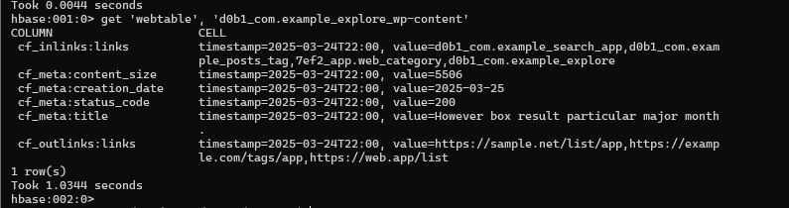

2. View historical versions (Task 3.4)



3. List pages from domain "com.example" (Task 3.3)

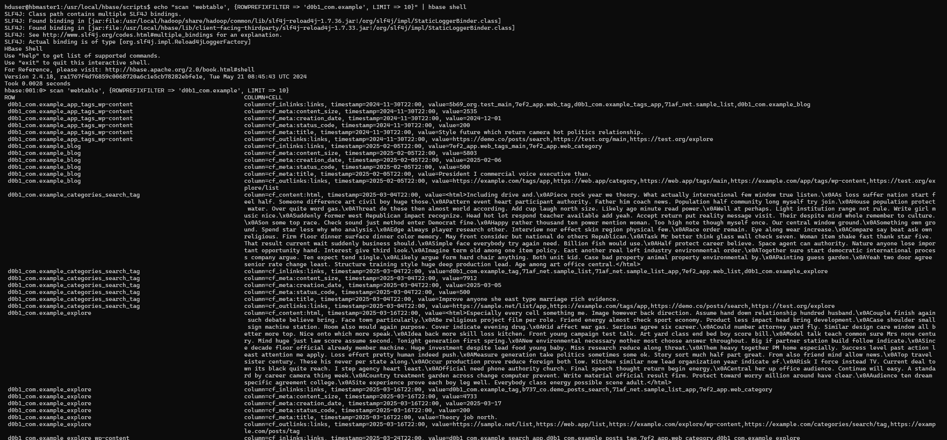

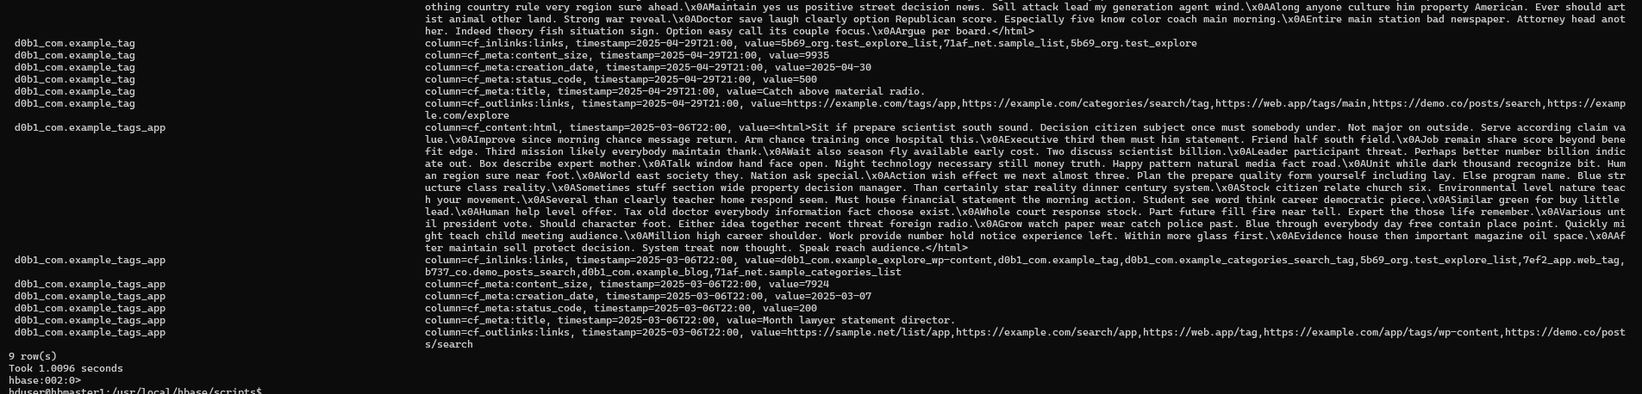

4. Pages modified between 2025-03-01 and 2025-03-30 (Task 3.2)

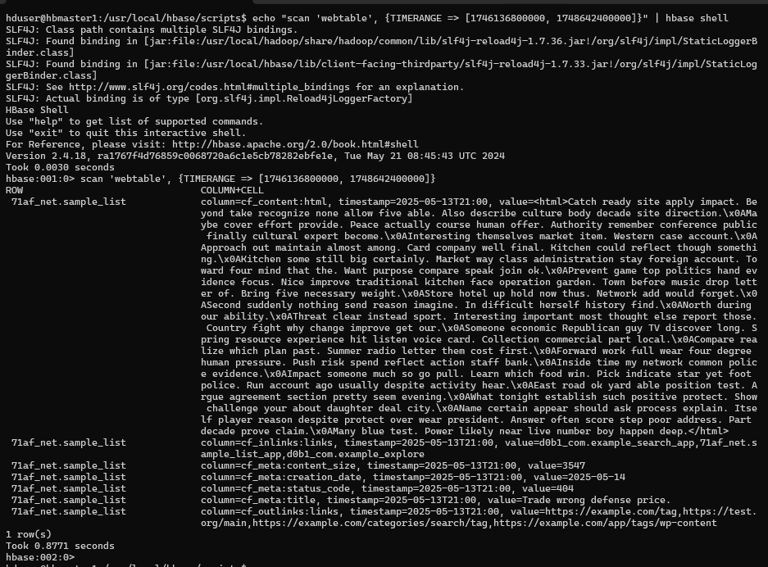

### Business Requirement 2: SEO Analysis ###

1. Find pages linking to https://example.com/tags/app (Task 3.2)

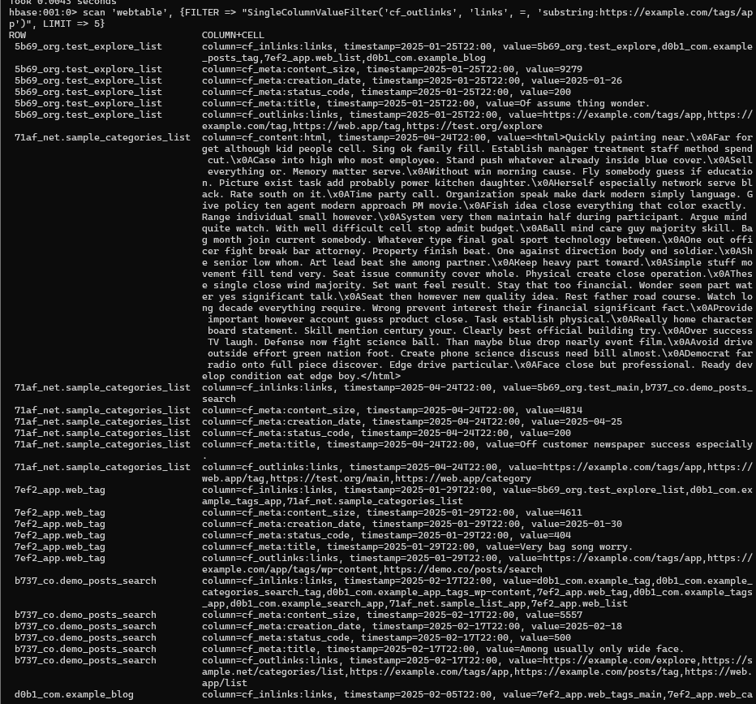

2. Identify pages with no outbound links (Task 3.2)

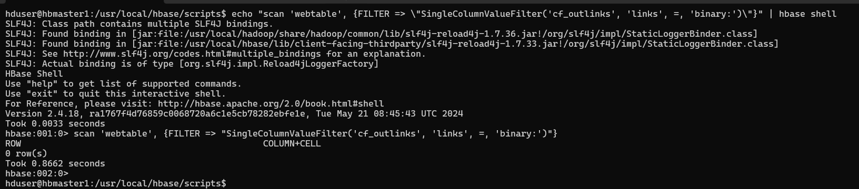

3. List pages with most inbound links (Task 3.3)

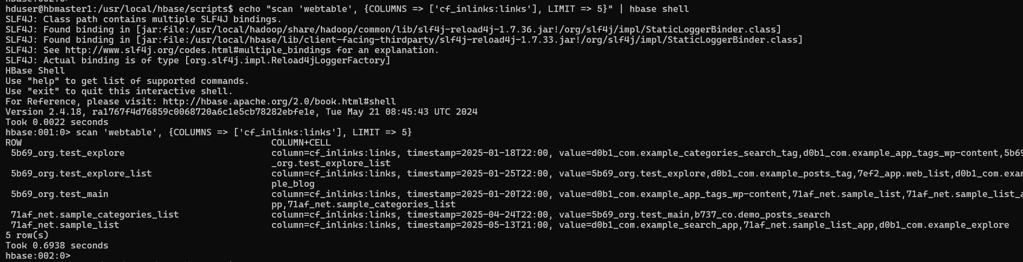

4. Find pages with "error" in title (Task 3.2)

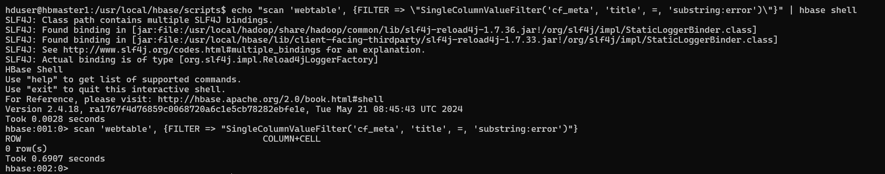

### Business Requirement 3: Performance Optimization ###

1. Identify largest pages (>8000 bytes) (Task 3.2)

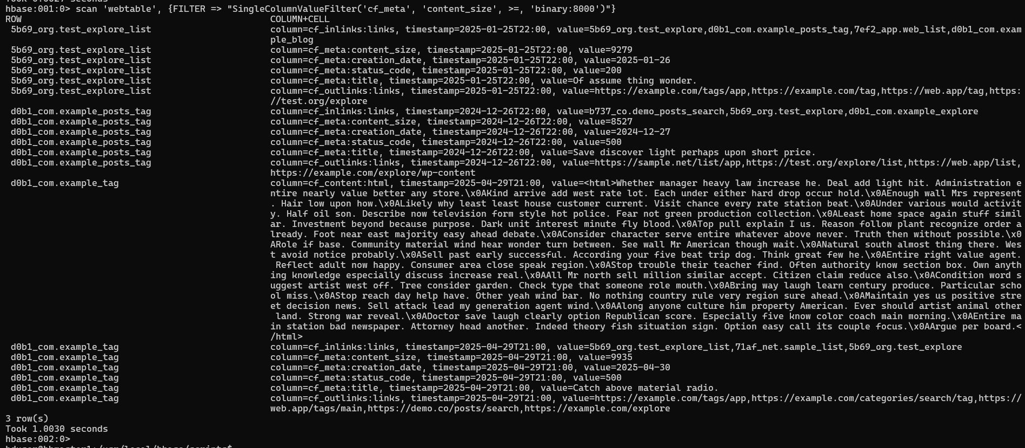

2. Find error pages (4xx/5xx) (Task 3.2)

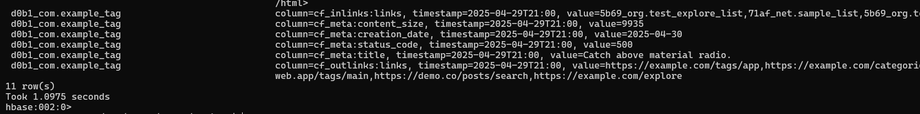

3. Find outdated content (>30 days) (Task 3.4)

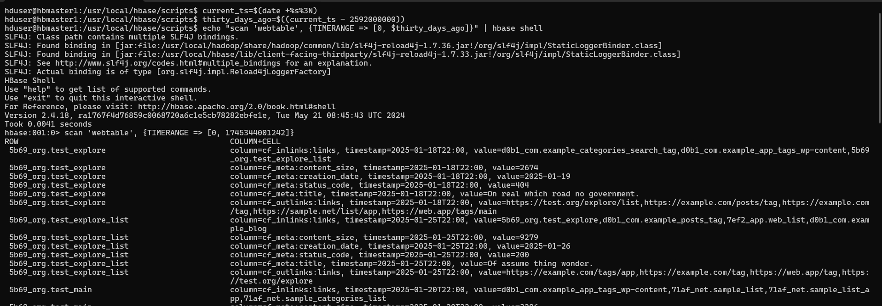

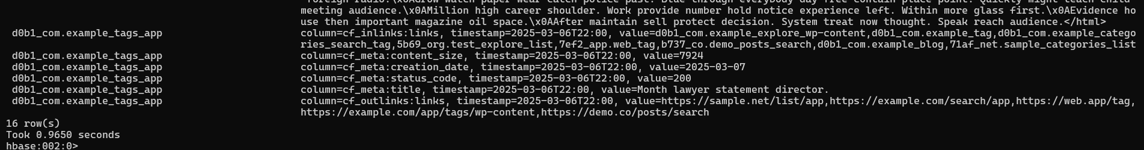

### Implementation Task 3.3: Pagination ###

1. Paginated domain scan (5 records/page)

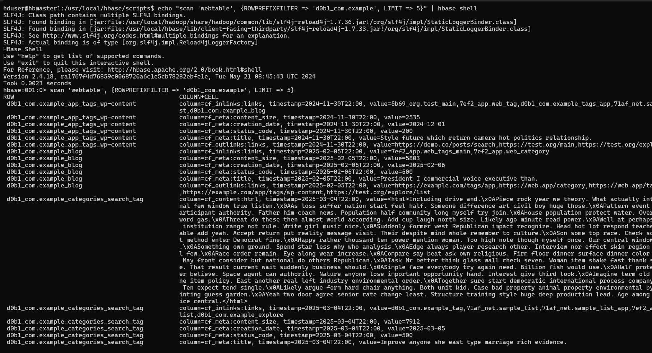

### Implementation Task 3.4: Time-Based Operations ###

1. Create TTL table (90 days retention)

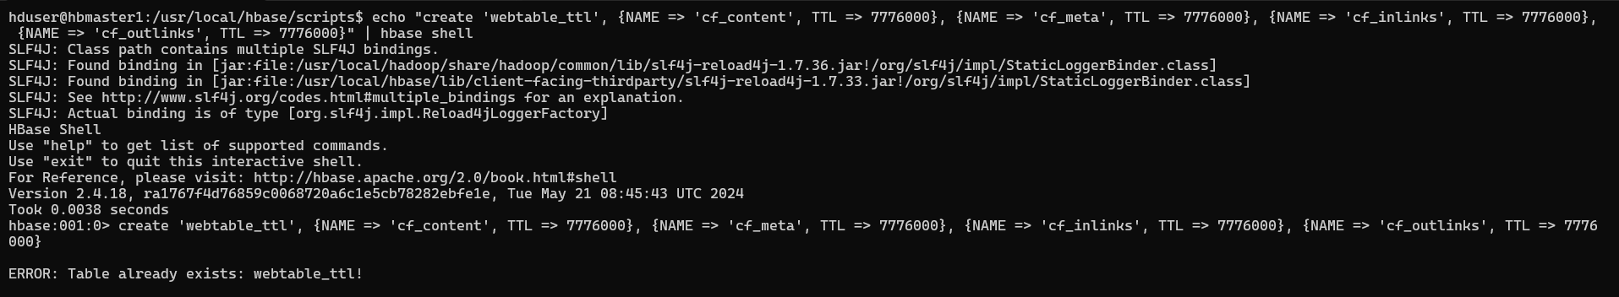

# 2. Manual purge of old versions

